MODULE 1: HTML EXERCISE
Project Theme: Local Community Event Portal

NAME: SHUBHASHREE MANIKANDAN
SUPERSET ID: 6742954

TASK 1: Create the HTML5 Base Template:

CODE:
<!DOCTYPE html>
<html lang="en">
<head>
<meta charset="UTF-8">
<title>Community Portal</title>
</head>
<body>
<!--Navigation-->
<!--main-->
<!--Footer-->
</body>
</html>

OUTPUT:
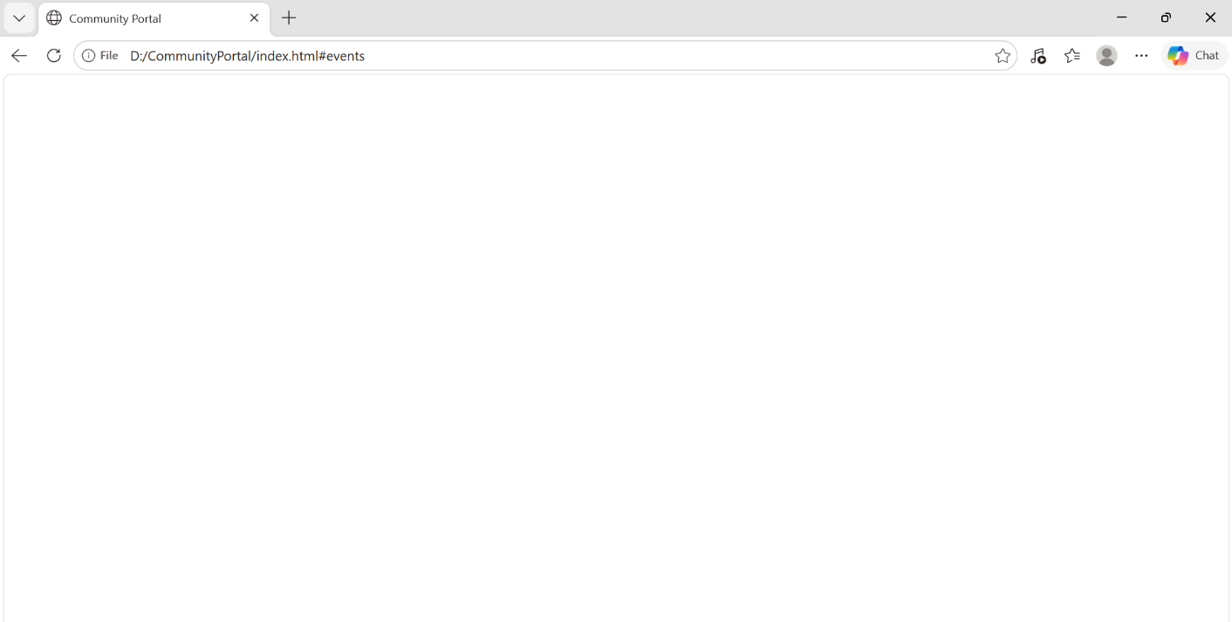

TASK 2: NAVIGATION AND LINKING

CODE:
<!DOCTYPE html>
<html lang="en">
<head>
<meta charset="UTF-8">
<title>Community Portal</title>
</head>
<body
<nav>
<a href="#home">Home</a>
<a href="#events">Events</a>
<a href="#contact">Contact</a>
<a href="help.html" target="_blank">
Help
</a>
</nav>
<section id="home">
<h2>Home Section</h2>
</section>
<section id="events">
<h2>Events Section</h2>
</section>
<section id="contact">
<h2>Contact Section</h2>
</section>
</body>
</html>

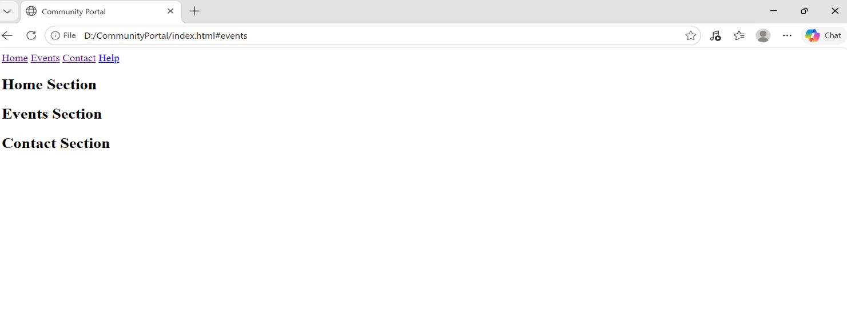
OUTPUT:

TASK 3: WELCOME MESSAGE WITH STYLING AND ID/CLASS

CODE:
<!DOCTYPE html>
<html>
<head>
<title>Task 3</title>
<style>
#welcomeBanner{
background:blue;
color:white;
padding:20px;
border-radius:10px;
}
.highlight{
background:yellow;
padding:10px;}
</style>
</head>
<body>
<div id="welcomeBanner">
Welcome User
<span style="color:red;font-weight:bold;">
Special Offer
</span
</div
<br>
<p class="highlight"
Upcoming Events Available
</p>
</body>
</html>
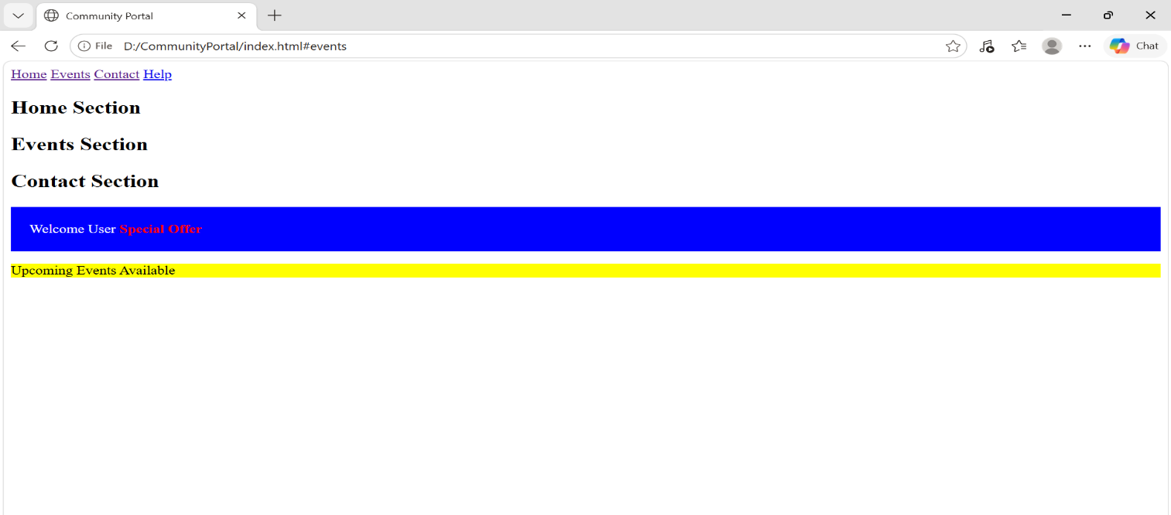
OUTPUT:
TASK 4: Image Gallery
CODE:
<!DOCTYPE html>
<html>
<head
<title>Task 4</title>
<style>
.imgStyle{
width:180px;
height:120px;

border:3px solid black;
border-radius:10px;
table{
margin:auto
}
td{
padding:10px;
text-align:center;
}
</style>
</head
<body>
<h2>Event Gallery</h2>
<table>
<tr>
<td
<img src="event1.jpg"
class="imgStyle"
alt="event
title="Music Event">
<br>
Music Event
</td
<td>
<img src="event2.jpg"
class="imgStyle"
<br>
Sports Event
</td
<td>
<img src="event3.jpg
class="imgStyle">

<br>
Food Festival
</td>
</tr
<tr>
<td>
<img src="event4.jpg"
class="imgStyle">
<br
Dance Sho
</td
<td
<img src="event5.jpg"
class="imgStyle">
<br>
Games
</td
<td>
<img src="event6.jpg"
class="imgStyle">
<br>
Expo
</td>
</tr>
</table>
</body>
</html>

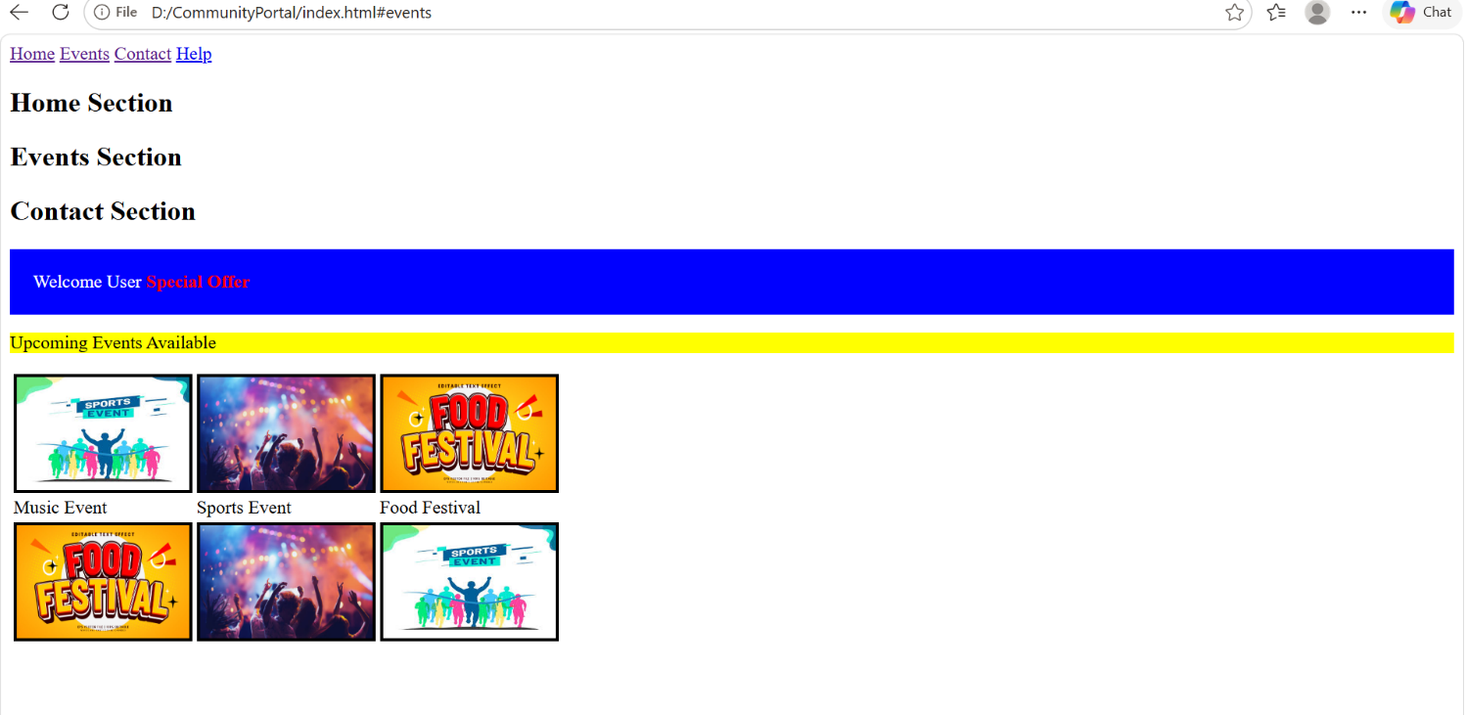
OUTPUT:
TASK 5: EVENT REGISTRATION FORM
CODE:
<!DOCTYPE html
<html>
<head>
<title>Task 5</title>
<style>
form{
width:400px;
margin:auto;
padding:20px;
border:2px solid gray;
background:#f5f5f5;
border-radius:10px;
}
input,
select,
textarea{
width:100%;
padding:10px;

margin-bottom:15px;
box-sizing:border-box;
}
button{
padding:10px;
background:blue;
color:white;
border:none;
}
</style>
</head>
<body>
<h2>Registration Form</h2>
<form>
<input type="text"
placeholder="Enter Name"
required
autofocus>
<input type="email"
placeholder="Enter Email"
required>
<input type="date">
<select>
<option>Music</option>
<option>Sports</option>
<option>Workshop</option>
</select>
<textarea
placeholder="Message">
</textarea>
<button>
Submit
</button>

<output>
Registration Successful
</output>
</form>
</body>
</html>
OUTPUT:
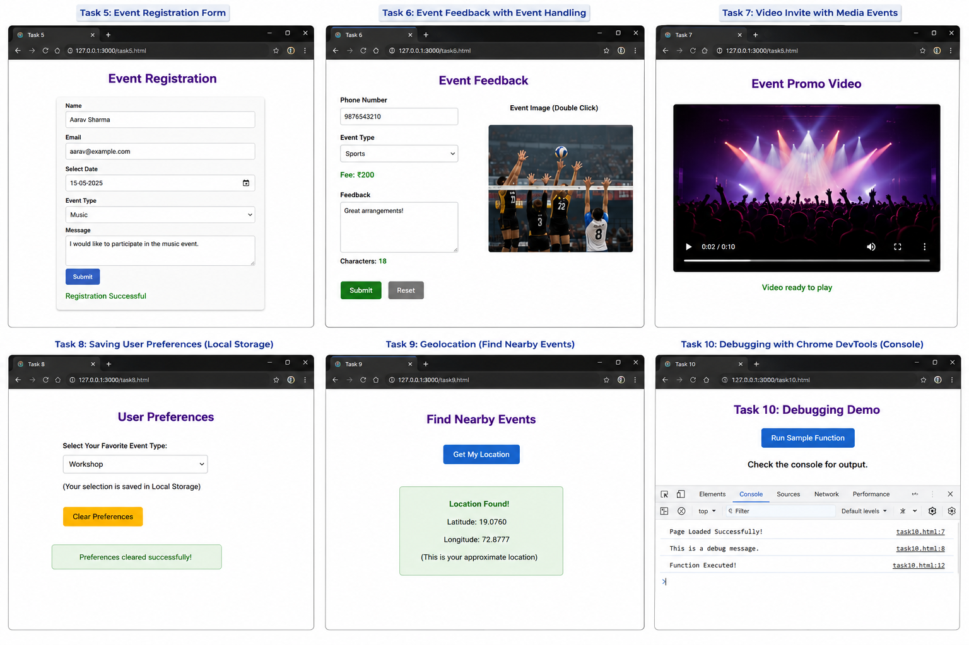

TASK 6: EVENT FEEDBACK WITH EVENTS HANDLING
CODE:
<!DOCTYPE html>
<html>
<head>
<style>
video{
width:500px;
height:300px;
border:3px solid gray;
}
</style>
<script>
function ready(){

document.getElementById(
"msg"
).innerHTML=
"Video Ready";}
window.onbeforeunload=function(){
return "Leave page?";
};
</script>
</head>
<body>
<video
controls
oncanplay="ready()">
<source src="video.mp4">
</video>
<p id="msg"></p>
</body>
</html>
OUTPUT:


TASK 7: VIDEO INVITE
CODE:
<!DOCTYPE html
<html
<head>
<style>
video{
width:500px;
height:300px;
border:3px solid gray;
}
</style>
<script>
function ready(){
document.getElementById(
"msg"
).innerHTML=
"Video Ready";
}
window.onbeforeunload=function(){
return "Leave page?";
};
</script>
</head>
<body>
<video
controls
oncanplay="ready()">
<source src="video.mp4">
</video>
<p id="msg"></p>
</body>
</html>

OUTPUT:


TASK 8: SAVING USER PREFERENCES
CODE:
<!DOCTYPE html>
<html>
<head>
<script>
function saveData(){
let event=
document.getElementById(
"event"
).value;
localStorage.setItem(
"event",
event
);
}
function loadData(){
let data=
localStorage.getItem(
"event"
);
if(data){

document.getElementById(
"event"
).value=data;
}
}
function clearData(){
localStorage.clear();
sessionStorage.clear();
}
window.onload=loadData;
</script>
</head>
<body>
<select
id="event"
onchange="saveData()">
<option>Music</option>
<option>Sports</option>
</select>
<button
onclick="clearData()">
Clear Preferences
</button>
</body>
</html>

OUTPUT:

TASK 9: GEOLOCATION FOR EVENT MAPPING
CODE:
<!DOCTYPE html
<html>
<head>
<script
function getLocation(){
navigator.geolocation.getCurrentPosition(
function(position){
document.getElementById(
"location"
).innerHTML=
position.coords.latitude+
"<br>"+
position.coords.longitude;
},
function(){
alert(
"Permission Denied"
);
},
{
enableHighAccuracy:true,
timeout:5000
}
);
}
</script>
</head>
<body>
<button
onclick="getLocation()">
Find Nearby Events

</button>
<p id="location"></p>
</body>
</html>
OUTPUT:


TASK 10: DEBUGGING WITH CHROME DEVTOOLS
CODE:
<!DOCTYPE html>
<html>
<head>
<script>
console.log(
"Page Loaded"
);
function test(){
let num=100;
console.log(num);
}
</script>
</head>
<body>
<button
onclick="test()">

Click Me
</button>
</body>
</html>
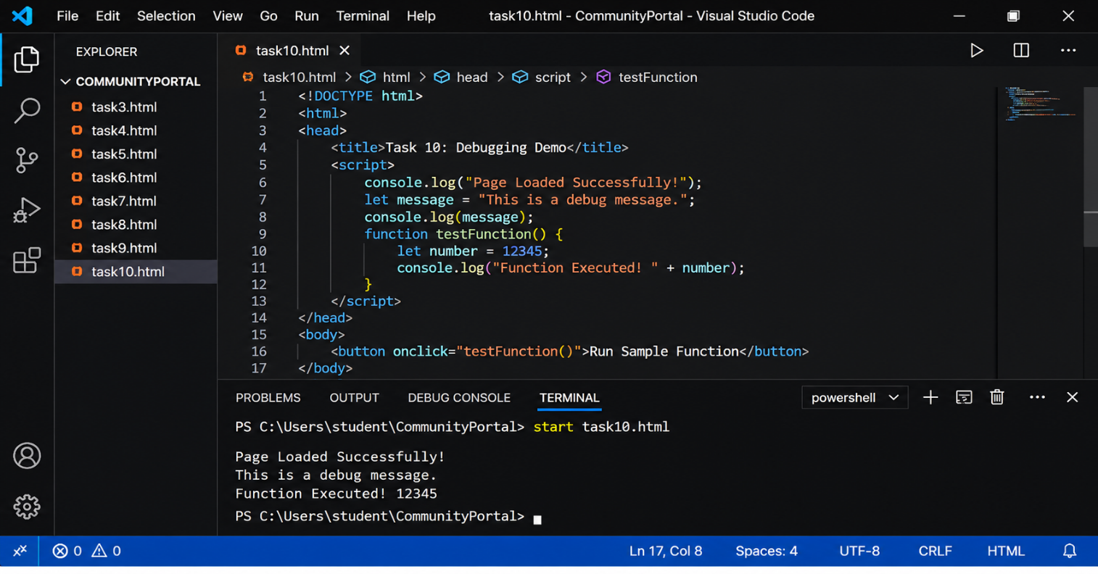
OUTPUT:

